Parkway Finance/Munis Guide

Last revised 7/24/17

Table of Contents

Account Segments 3

Account Inquiry 6

Vendors 9

Vendor Inquiry 10

Invoice Entry 14

Pcard Processing 19

Invoice Maintenance 24

Journal Entry 25

Fixed Assets 27

# Account Segments

**11.2222.333.44.5555.66666.7777.88888**

**Fund**- Building or Student Activity

**11**.XXXX.XXX.XX.XXXX.XXXXX.XXXX.XXXXX

10= Building

11= Student Activity

12= Benefits Fund

30= Debt Service Fund

40= Capital Projects/ Large Equipment

41= Student Activity Capital Projects/ Large Equipment

**Function**- Which Department it falls under per DESE – If you are using a function code that still ends in Zero, it will be changing to meet DESE requirements.

XX.**2222**.XXX.XX.XXXX.XXXXX.XXXX.XXXXX

1111= Elementary

1131= Middle School

1151= High School

2551= Non Parkway Transportation

2552= Parkway Transportation Services

**Program-** Used to determine which Department in the school that will use this code

XX.XXXX.**333**.XX.XXXX.XXXXX.XXXX.XXXXX

Range from 000-900. Given more specifics by division/ school. Mainly see 000-150

**Location-** This field currently identifies the location within Parkway. We will have to begin reporting expenses by location code to DESE on July 1, 2018 using a 4-digit code assigned by the state. This field will be changing this year.

XX.XXXX.XXX.**44**.XXXX.XXXXX.XXXX.XXXXX

**Object**- Tells auditors/ DESE what type of expense it is – DESE does not want object codes that end in Zero. All object codes that currently end in zero will be changing this year.

XX.XXXX.XXX.XX.**5555**.XXXXX.XXXX.XXXXX

Range from 1101-9000

1101-4999- Balance Sheet Accounts (most common is 1101- Cash)

Only Pay from balance sheet accounts related to Fund 12 expenses

5100-5999- Revenue (most common is 5170); must deposit money into Revenue codes

NEVER Pay or Process Payroll from a Revenue account NEVER

6000-9000- Expenses (most common listed below)

<6300- Payroll Related Expenses, ONLY for Payroll

6330- Property Services

6343- Travel

6360- Other Purchased Services

6410- General Supplies

6430- Regular Textbook

6541- Equipment General

Common Object Codes

**6342‐Other Contracted Transportation‐**Used for busses district or non‐district

**6343‐Travel**‐Used for any District personnel only, traveling in or out of the district for district purposes. Examples include conference registrations, mileage throughout the district, mileage to a conference, airfare, meals and expenses related to trips without students.

**6360‐Other Purchased Services**‐These include services that the district or school could perform ourselves, but for whatever reason we have decided to pay someone else to do it. Examples include printing/ copier expenses, catering, and hosting events.

**6410‐General Supplies**‐This is for general use items throughout the district. Examples include most Staples orders, basic supplies, and general equipment under 1,000.00 usually used by district personnel

**6430‐Regular Textbook**‐This is for supplies and materials related to student instruction at various levels. Examples include Textbooks, student computers under $1,000.00, supplies students use 100% of, and student workbooks.

**6541‐Equipment General**‐At the risk of repeating myself, use these codes for any single item over 1,000.00.

**6542‐Instructional Equipment**‐Use these codes for any single item over 1,000.00 used primarily by the students.

**Sub- Object**- Provides auditors more specifics about the type of expense

XX.XXXX.XXX.XX.XXXX.**XXXXX**.XXXX.XXXXX

**Future**- Very Rarely used, but helps sort certain expenses. Almost always 0000. This segment may be changing to accommodate the DESE requirements for location.

XX.XXXX.XXX.XX.XXXX.XXXXX.**XXXX**.XXXXX

0000= General Use

1110= Elementary Education

1130= Middle School Education

1150= High School Education

**Project**- Identifies certain accounts (most often Student Activity Accounts) within a building. Each person in charge of these projects should know and understand their project codes. Each building has different ones. (i.e. “I need the soda account balance.”)

XX.XXXX.XXX.XX.XXXX.XXXXX.XXXX.**XXXXX**

**Key Bullet Points of Information:**

**Building vs. Student Activity**- Building Accounts start with a 10 or a 40 and Student Activity accounts start with an 11 or a 41. Building accounts have taxpayer allocated budgets. Budgets set and allocated for the next year in March, must have board approval to transfer. Student activity accounts are cash collected from students and the budget increases each time a deposit is made into that account. SA revenue accounts are for cash/ check deposits only.

**Journal Entries vs. Invoice Maintenance-** An invoice maintenance is used to move a current year paid expense to the correct account. In order to do an invoice maintenance, we must have made the payment through Accounts Payable. If it is our mistake, we fix it with an email. Otherwise, please complete the Invoice Maintenance form. This form can be found on the Google shared drive. Use a journal entry to correct any expense that was charged to your account via a journal entry (i.e. bus costs, copier costs).

# Account Inquiry

Account Inquiry is one of the most useful tools in Munis.

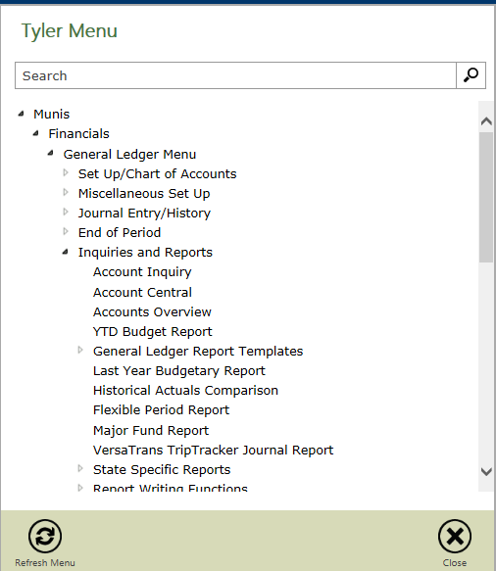

The account Inquiry can be used to help you investigate what has been charged to an account. It can also be used as a tool to look at all of your accounts at one time (and in total). When using account inquiry to look at all of your accounts use your “roll up” code as the search criteria. This will ensure that you pull all of the accounts that fall within your budget. If you are in a school, your rollup code will be your location. If not, then it may be your department. You can determine what your rollup code is by looking up one of your accounts.

To search all of your budget accounts, click on the “search” button, enter your rollup code and select “active” in the status field (this will prevent you from seeing accounts that have been inactivated).

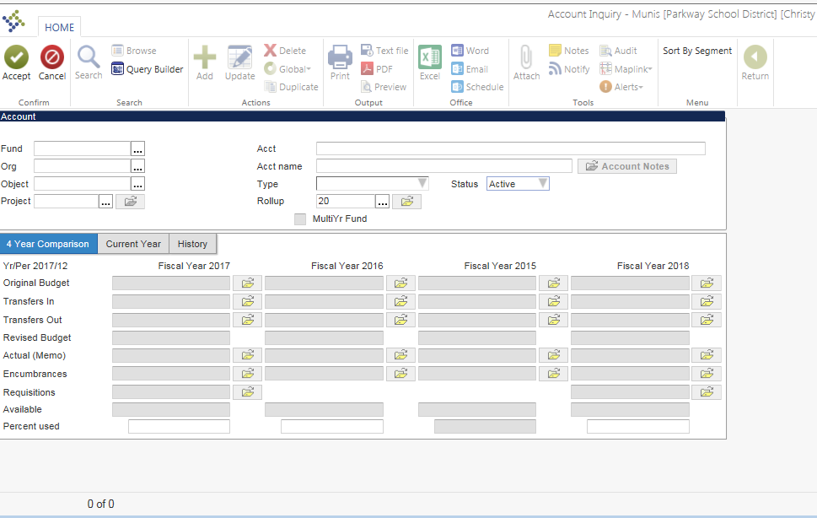

Once you click Accept you will see the following. Notice at the bottom it tells you how many accounts your search found (use the arrows to toggle between them or click browse to see the entire list). If you click on the “totals” button (top right) this will sum all the accounts that your search pulled. This is a great way to do a spot check of where you stand on your budget. Once you are finished with your total click the return arrow (top right) to get back to the account inquiry screen.

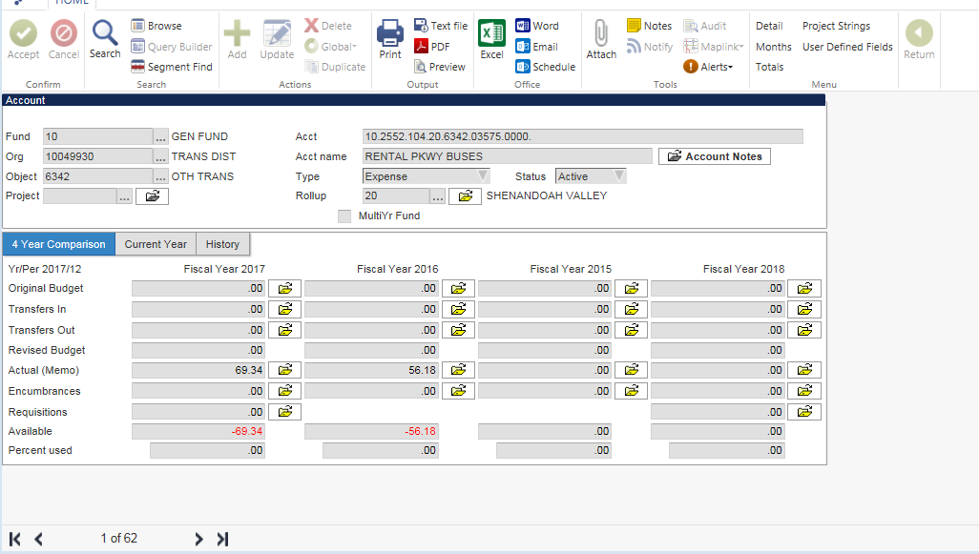

Original Budget – This tells you what you entered when you did your budget entry.

Transfers In and Transfers out – This would be you budget roll forward and any additional budget adjustments that you requested. On student activity accounts the Transfers in are your deposits made to that student activity.

Actual (Memo) – All expenses that have been charged to this account.

Encumbrances – Amounts open on PO’s. Amounts on Open PO’s will reduce your available budget. Make sure you periodically check to see if there are any open PO’s that need to be closed.

Requisitions – Amounts that you have entered on Requisitions that have not yet been converted to a PO. Once it is converted the amount will move to the encumbrance field.

# Vendors

The vendor files are going through a cleanup process. Here are some things you need to know about the vendor process.

* We use the “vendor type” field to help organize vendors. If you are looking for an employee vendor, selecting that vendor type will help narrow your search.
* Active vs. Stopped vendors – You may only use a vendor if they are active. If a vendor has been stopped, we probably need a w-9 on file.
* We can NOT have 2 vendors with the same Federal Tax ID number (FIN or EIN). We would utilize additional addresses to accommodate several business names that are associated with the same EIN.
* Employees and Parent/Student refund Vendor Types will not require a w-9. When you select these vendors you will get a warning that you can just bypass. All other vendors should have a w-9 on file.
* If you do not find a vendor in Munis and need to add it, please contact the Accounts Payable person in charge of that vendor letter. The breakout of A/P responsibilities is listed below.
* Vendors now go through an approval process. This helps ensure that the information that is entered is accurate. Please give 24 hours between your request to set up a vendor and using the vendor to allow for the approval process.

**AP Breakout**

**TaSha**- A-H and Sam’s Club

**Mary**- I-N, Amazon (moving to P-Cards), Travel, and Utilities, American Airlines

**Joan**- O- Z, Bond, Schnuck’s, EFT startup

**Maria**- Accounts Receivable (Deposits), Credit Apps, Camp, Food Service Accounts Payable, Petty Cash and P-Card

# Vendor Inquiry

Vendor Inquiry is a great tool when you don’t know if a vendor exists in Munis or you need to look up a vendor number. It is also the place to go if you want to know the status of an invoice or issued check.

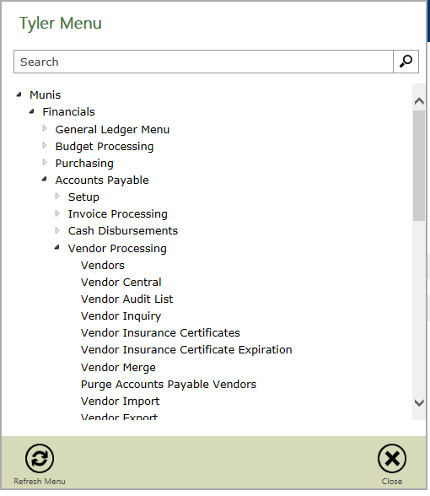

You can search for a vendor by clicking on “search” and then filling in some details. I like to use the company name field and use the (*) when searching by name. The (*) is like a wildcard. In the example below, it will give me anything that has “GRONER” in the company name field. This is an important tool when you are unsure of the full name of the company. You can also search by vendor type, status, or FID (if you know it).

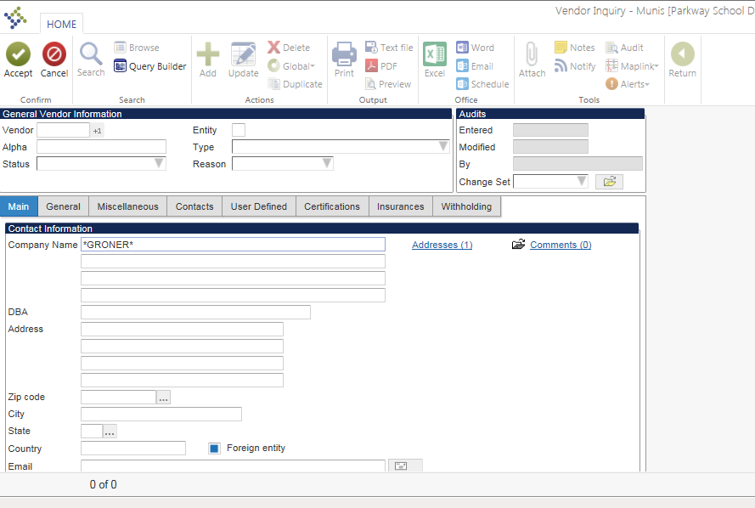

If your search results in many possibilities, you can click on the browse button to see a list of the vendors that fit your search criteria.

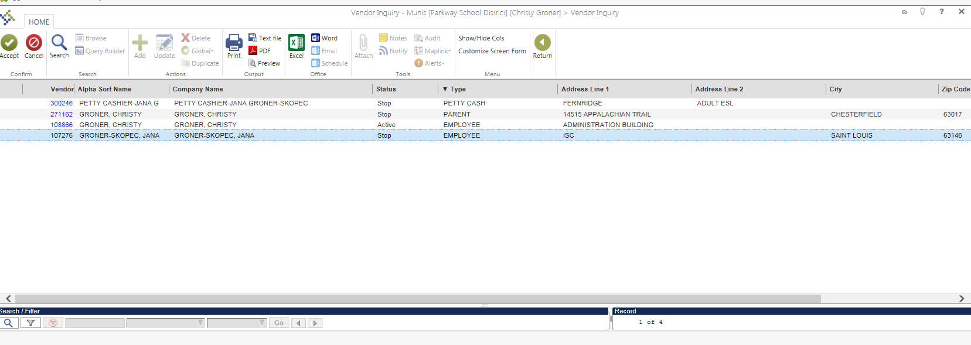

In the browse screen, you can rearrange the order of the list by clicking in the gray header bar. If you want to sort by status, click on the word status and it will sort the data. You can right click in the header to choose different fields that are available for viewing. You can also rearrange the order of the columns by clicking on the header and dragging it to where you want it to be. If you compare the screen shot above to the one below, you will see that I moved the status column to the left and sorted so that Active vendors would be listed first. **This can be done in any “Browse” screen within Munis.**

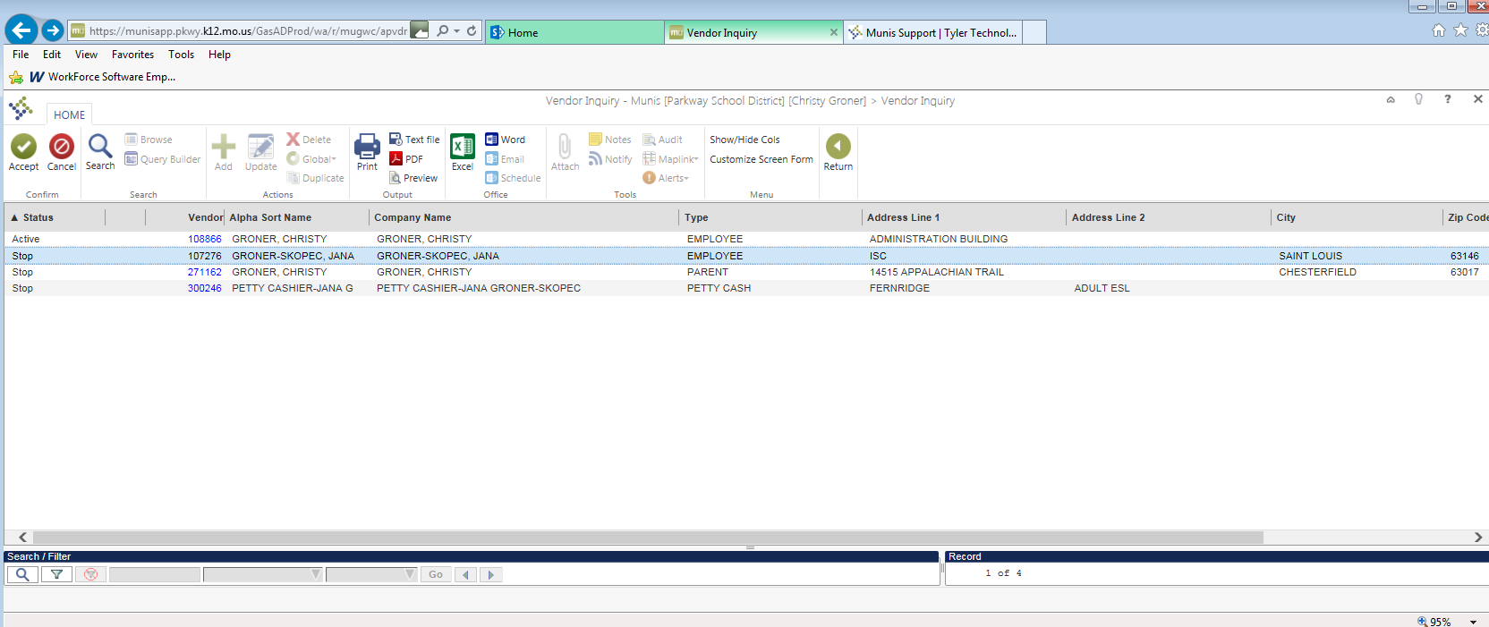

If you need to look up the status of an invoice or issued check you would do so on this screen. Once you find the vendor, click on Invoice Inquiry or Check Inquiry.

Invoice Inquiry: When you click on invoice inquiry you will need to give Munis some parameters. If you know the year of the invoice, then enter the year (leave the period blank) and select the blank row in the status field. This will give you every invoice during that year regardless of the invoice status. If you do not know the year, you can leave it blank as well. This may result in a large number of invoices for some of the vendors.

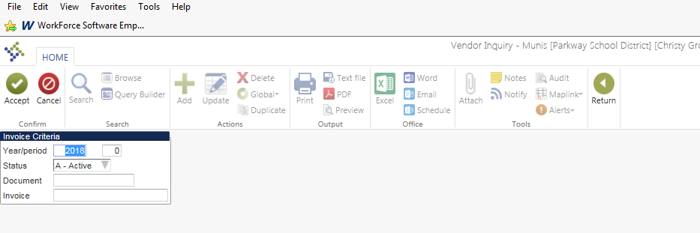

The invoices that match your search criteria will be pulled into a list. This list can be sorted by clicking in the header row on the column you want it to sort by. Double click on the invoice that you want to see and it will pull up the Invoice information. From here, you can look at the attachment. If you need to see the account code that was charged, click on “Detail” (top right).

Check Inquiry: When you select Check Inquiry you can specify check number or date. The search results will pull in as a list that can be sorted (just like invoice inquiry). **This is where you will need to go if you need to see if a check has cleared our bank.** Checks are cleared in Munis once a month so keep that in mind when you are doing this research. If you do not see that a check is cleared and want to check the current month, you will need to reach out to the A/P person in charge of that vendor.

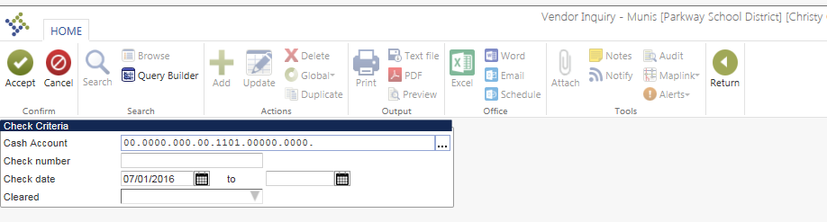

You can also search for vendor PO’s from this screen. Keep in mind that when you search from the vendor inquiry screen, your results not narrowed down by your location (the information will be district wide).

# Invoice Entry

Invoice Entry (used to be called Order for payment or E payment) is used when paying a vendor for something when you do not have an approved PO. The invoice must be less than $1,000 (less than $500 for employee reimbursements). This invoice will go through the same Munis approval chain that a requisition would go through.

Login to MUNIS and from the Tyler Menu Select Invoice Entry:

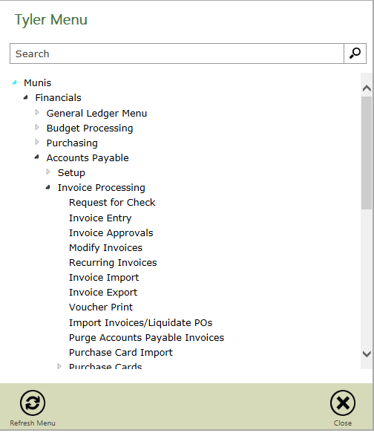

The first time you are here, I recommend right clicking invoice entry and adding this to your favorites or my programs.

Once the Invoice Entry pops up, select “Add Batch”. It will default to all the correct information from here. DO NOT CHANGE THIS DATA! Just hit the green check mark in the upper left hand corner.

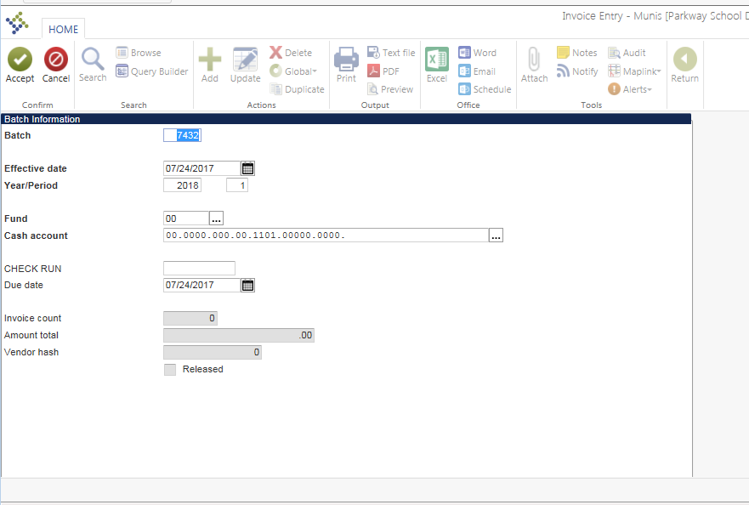

Once you accept you will see this screen:

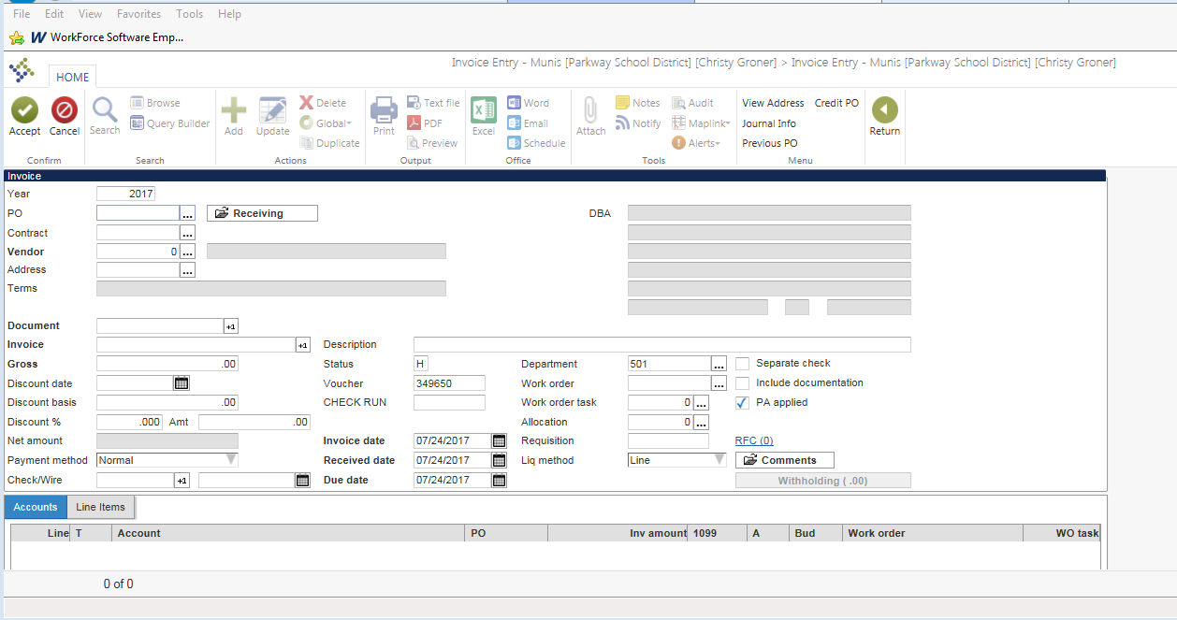

There are a lot of fields on this screen. The following are the fields that you need to focus on (tab through all other fields):

**Vendor:** If you do not know your vendor number click on the (…).

* Search in ALL CAPS, and use a simplified version of the name that you are searching for. Keep in mind Wal-Mart could be entered as WAL-MART, WAL- MART, or WALMART. This is one of the few places in Munis that you do not want to use the (*) in your search.
* If this vendor does not exist in the system, a new vendor must be set up for them to be paid. Please reach out directly to AP if you do not have the vendor you are looking for. We will need a w-9 from the vendor to get them set up properly.
* If you get an error saying that the vendor is status “S”, it means that this vendor has been stopped. Typically, it was stopped because we need to get a w-9 from the company. If you need help getting a w-9 please contact the Accounts Payable (A/P) person in charge of the vendor letter.

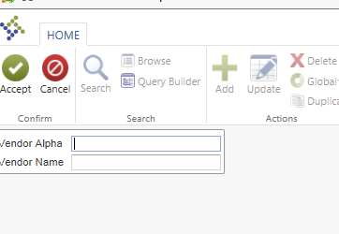

**Address:** Make sure you select the address that the check is to be sent to (remit to address). If we need to add an address in Munis contact the A/P person in charge of that vendor.

**Document:** Click the +1 button to the right of the field. **Do NOT enter anything manually into this field!**

**Invoice:** Enter an “E” followed by the invoice number on the invoice you are paying. The “E” is an important identifier for Purchasing.

**Gross:** Invoice Amount

**Description:** Description of purchase

**Invoice date:** Date on invoice (do not change the received date or due date).

**Account:** Enter the account code that you are charging the expense to. You may use more than one (1) account code but the total must equal the Gross amount that you entered.

Once you have completed the invoice you will need to attach the document that supports your entry. Click on the paperclip (top center) and select AP Invoice (double click on AP invoice or click once and select “view documents”)

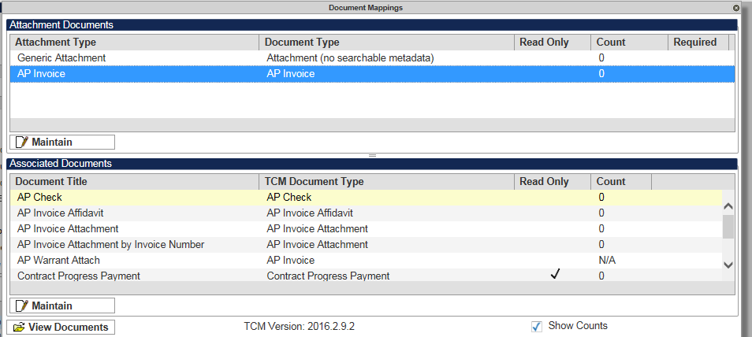

Select “New” then “Import” (If you have a scanner hooked up to your desktop, you may choose “scan” instead of import. This will require some work on your part to figure out depending on how your scanner is set up).

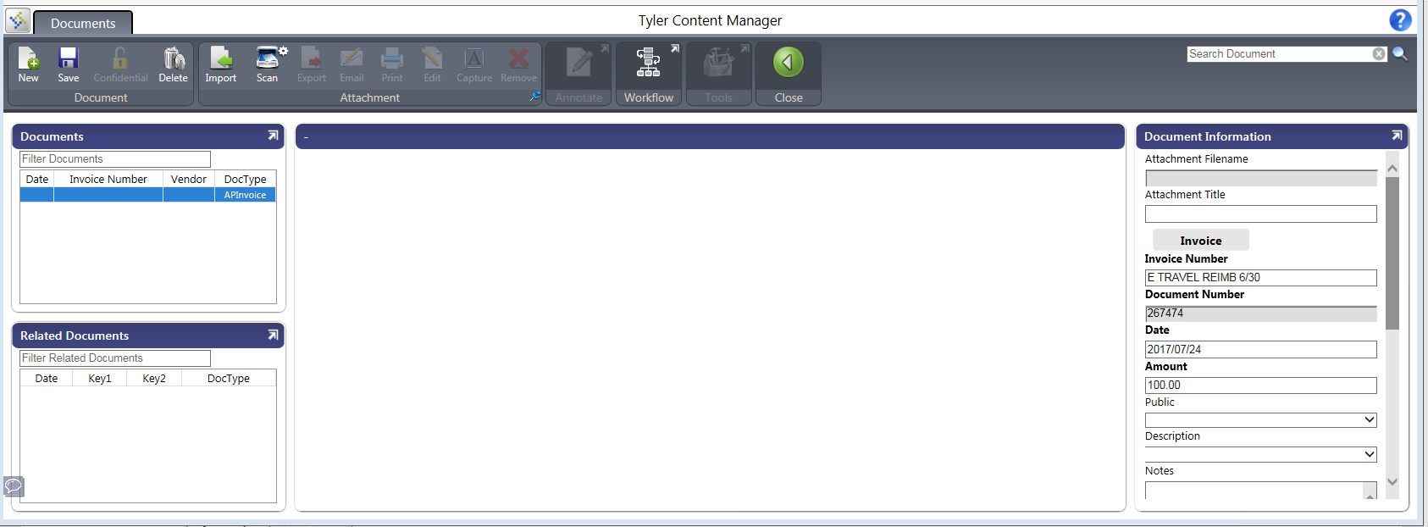

Select “Choose File” and select the file that you want to attach and click “Import”.

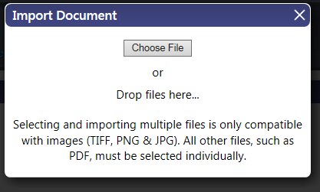

Most importantly, click **“SAVE”.** If you do not save, the invoice will not be attached. This attachment is tied to the invoice number. If for any reason, you change the invoice number on your entry, the attachment will have to be reattached.

Each invoice entered in a batch will go through the approval process. If you have multiple invoices to pay to the same vendor, you may enter them in the same batch. To do this you would click the “add” button after you complete the first invoice. Do not put invoices to different vendors in the same batch as this could slow down the payment process.

Once completed click accept then return to get back to the Batch Screen.

**Final Step – Verify and release**

On this page verify that the Invoice Count and Amount Total matches what is actually in the batch. Then select the release Button and then the Approvals button to put it in the Workflow.

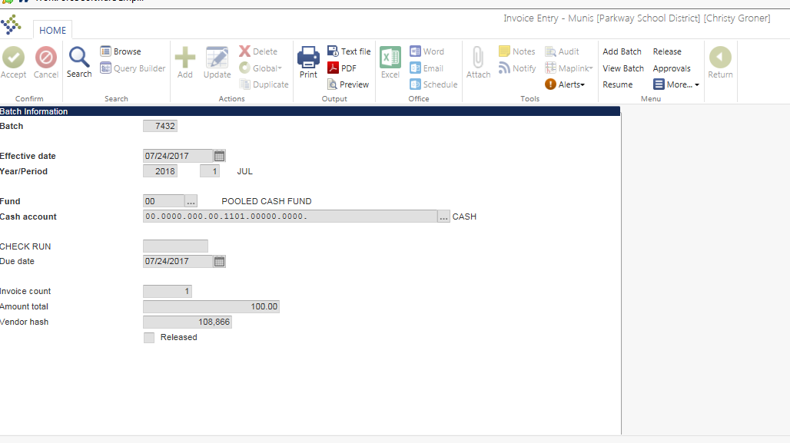

Finance will be the first approval stop for these entries. We will be checking: Vendor, remit address, invoice number, description, account code and verifying the attachment is valid.

If you want to check the status of your batch, go to the Invoice Entry screen and click browse. This will show you all of the batches that you have entered but have not been posted for payment. **If your batch is not on this list, it has been posted for payment.** When you find the batch you are looking for, double click on it then click “view batch” (top right). Double click on the invoice to open the entry screen. On the bottom right you can click on the “approvers” button to see where it stands in the approval process. If there is something in the “Check run” field, it means that A/P has done the initial approval and are watching for completion.

# P-Card Processing

P-Card statements will be uploaded into Munis and you will be notified when they are ready for you to process. The P-Card statement module can be found under Finance/Accounts Payable/Invoice Processing/Purchase cards.

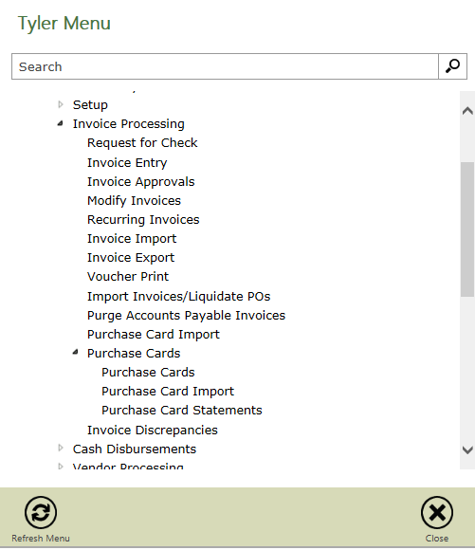

To select your P-Card statements for processing search on the Status field. If you are not seeing a P-Card that you are responsible for reconciling, please contact Christy Groner.

* New = Statements that have been uploaded but not released.
* Released = Statements that have been released into workflow.
* Approved = Statements that have completed the approval process.
* Rejected = Statements that have been rejected at some point in the workflow.
* Converted = Statements that have been posted and are considered complete.

This search will pull up the Statement page (see below).

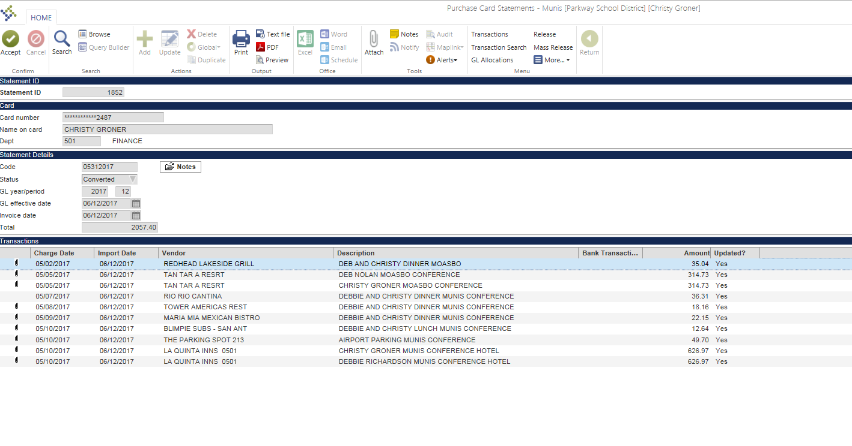

You will need to click on “Transactions” (top right) to get to the detailed transactions. This is where you will update the information for each transaction.

Click Update. It will default you into the description field, please keep the description close to the name on the receipt but add as much detail as you would like in ALL CAPS.

Next tab down into the allocations, it will default you an account code that you do not have access to, you must change the account code to the correct place within your budget.

Tab through and allocate across multiple if necessary, similar to the way that you do within a requisition.

Hit the green check button in the top left hand corner of the screen to save everything that you just entered.

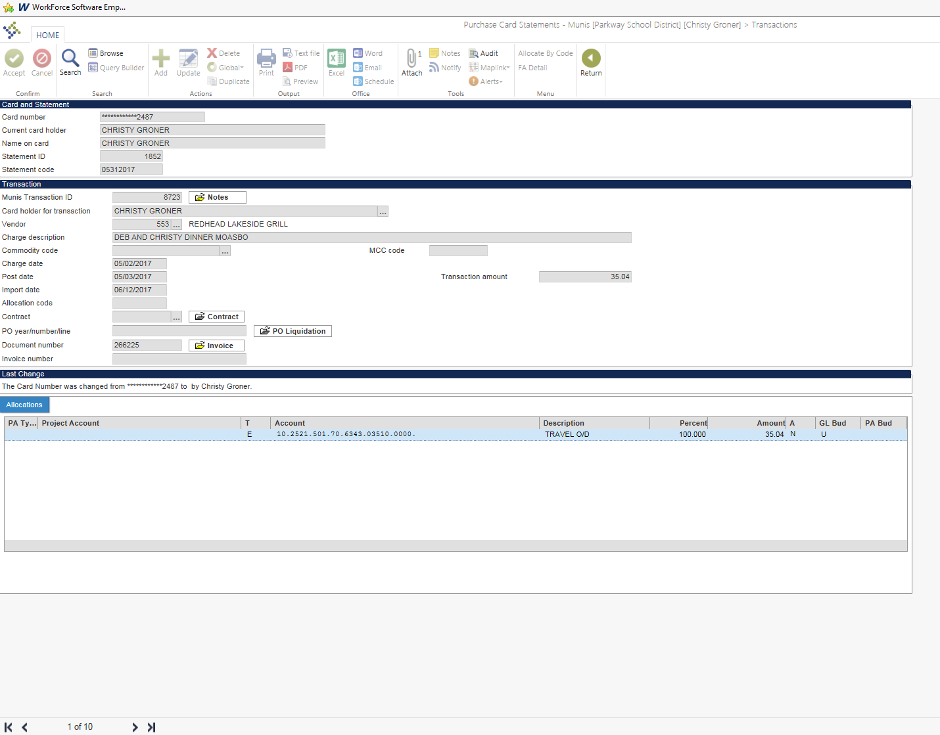

Next hit the paper clip in the top bar shown above. This will bring up the Document Mapping. You must select **Purchase Card Transaction** when attaching these items. Click view documents.

Select “New” then “Import” (If you have a scanner hooked up to your desktop, you may choose “scan” instead of import. This will require some work on your part to figure out depending on how your scanner is set up).



Select “Choose File” and select the file that you want to attach and click “Import”.



Most importantly, click **“SAVE”.** If you do not save, the receipt will not be attached.

Once completed click accept then return to get back to the Batch Screen.

Attachments should be an itemized receipt for the purchase. A/P will be looking to ensure the following:

* Receipt is itemized
* If the vendor is a Missouri vendor, Parkway does NOT pay sales tax. The card holder will be responsible for reimbursing Parkway for any tax money charged on the receipt.
* Description is appropriate
* Account code has been updated.

Repeat this process until every transaction on the statement has been updated.

If you would like to add notes to the statement for future approvers, including Maria or other approvers, click notes under statement details. This is where we recommend putting statements such as “Taxes paid on Office Depot transactions dated 07.06.2015. “Repaid on 07.08.2015 when receipt turned in.” If you are sending over money for taxes or a lost receipt, A/P will not approve the P-Card statement until that reimbursement is received in Finance.

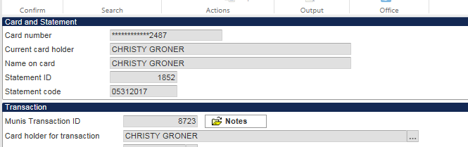

Once all records have been updated click “return” until you get out to the Purchase Card Statements screen. If all the transactions related to a card have completed, click on the release button (top right).

This will send it into the approval process and will change the status on the statement to released.

If you would like to get a PDF report of your statement you can click on the PDF button on the P-Card Statement screen.

You should not use the P-Card to avoid purchasing procedures. Finance/Purchasing will revoke P-Card privilages if you violate the contract you signed or if you do not stay current on your reconciliations in Munis.

# Invoice Maintenance

If an invoice has been paid to the wrong account, please complete the invoice maintenance form located on the Budget Secretary shared Google drive. Forward the completed form and the backup attachments to Deb Nolan and Christy Groner to be completed. If you have a question about whether to do an Invoice Maintenance or a Journal entry, please ask.

# Journal Entry

Journal entries are entries that can be made to “reassign” expenses that were charged to an account via a journal entry. Journal entries should not a routine occurrence. In many cases errors should be corrected using Invoice Maintenance. If you have questions regarding when you should or should not post a Journal entry, please contact Christy Groner or Deb Nolan for clarification. If your journal entry is between accounts that you have access to, you can enter it yourself. If not, you will need to fill out the Journal Entry request form on the Budget Secretary shared Google drive.

Select: General Journal Entry/Proof

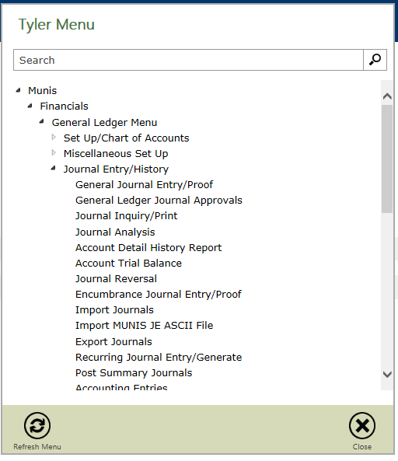

Click “add”.

Fill in the information.

Fields:

* Short Description: 10- Character Description of the Journal
* Journal Reference: 6- Character Description, the one you will see on summaries
* Reference 2: 10- Character Description- make it match or closely match the Short Desc.
* Reference 3: Your user id (i.e. “CGRONER” or “DNOLAN”)
* Always complete the line description. It will auto populate after the 1st line but update it if necessary by line.
* You must select debit or credit for each line (D or C)
* Debits and credits at the bottom of the screen should balance when the journal is complete. If it does not, review it and correct the error.
* If your journal entry has account codes with different fund (1st two digits of account code) the system will create a couple of extra lines to balance the entry by Fund. If you are doing a recurring journal or a journal import you will have to manually create these Due to/Due from (DT/DF) lines. If you want to verify that your funds are in balance click on “Summary” (top right).

Use the screenshot below for guidance.

Once you have completed your journal, you must attach something to back up the entry. That attachment can be made under Generic Attachment or Journal entry attachment (if using the journal entry attachment do not forget to hit SAVE when complete). The attachment should contain the following information:

* + Administrative authorization to use each account involved
  + Purpose of the journal entry
  + Detailed support to justify each item

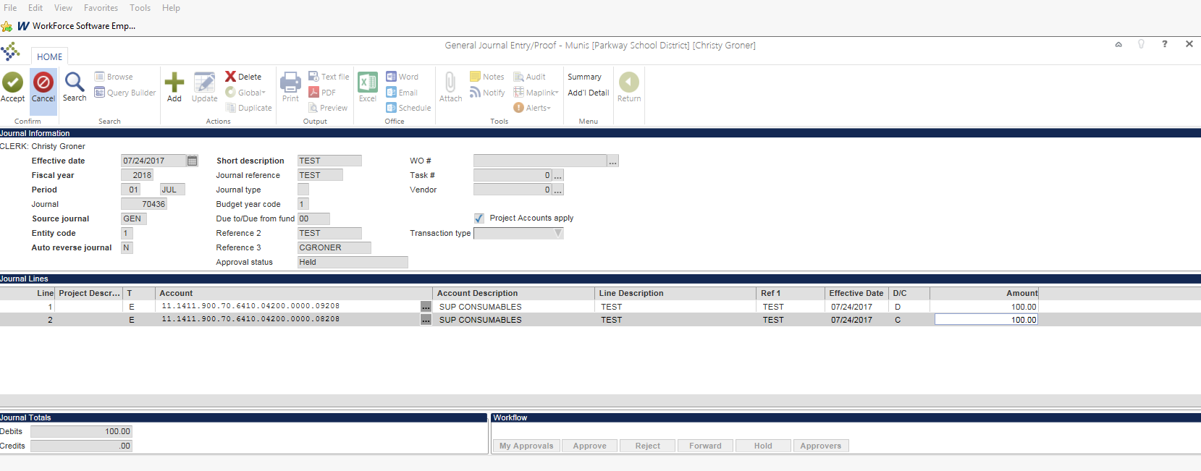

When completed select “more” (top right) and release the journal. This will begin the Journal approval process. Every journal is reviewed by someone in finance before it is posted.

**Journal Entry Quick Checklist:**

* Verify Date and Title
* Debits equal Credits
* Attachment
* Summary
* Released

# Fixed Assets

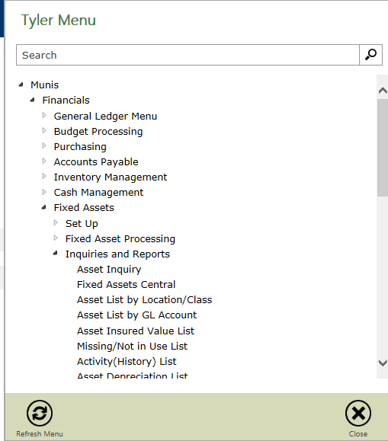

To pull your fixed asset report go to Asset list by location/class. Click on Define (top right).

Enter the search Criteria needed to find your assets:

Make sure you edit:

* Location: Your Location Only
* Acquisition Date: 07/01/1901- Most Recent Month End
* History date: 07/01/1901- Most Recent Month End
* Asset Status: **Active Only- Most Important part**

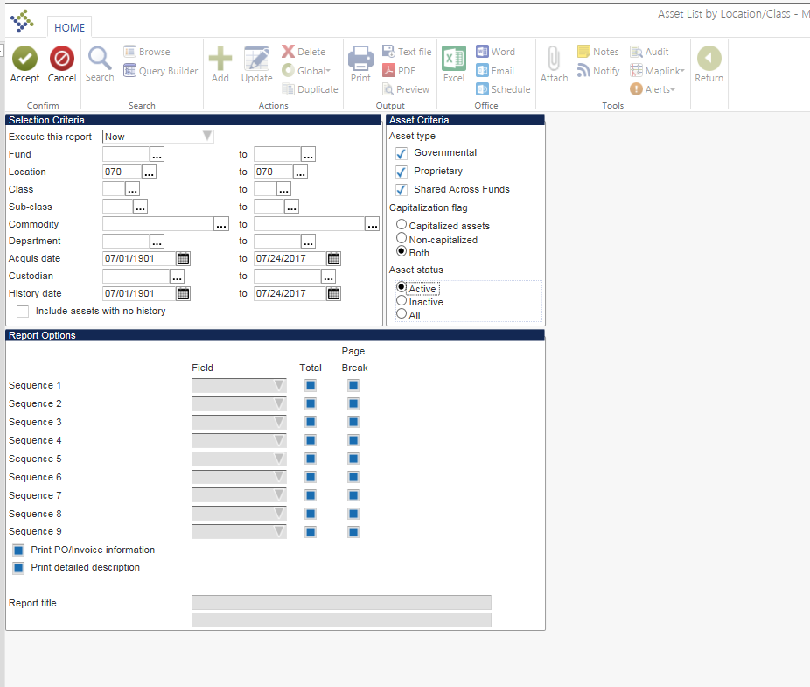

Click Report Options.

Enter the following report options:

* Sequence 1: Department- with a Total and Page Break checked
* Report Title: Building Asset List and your Sequence

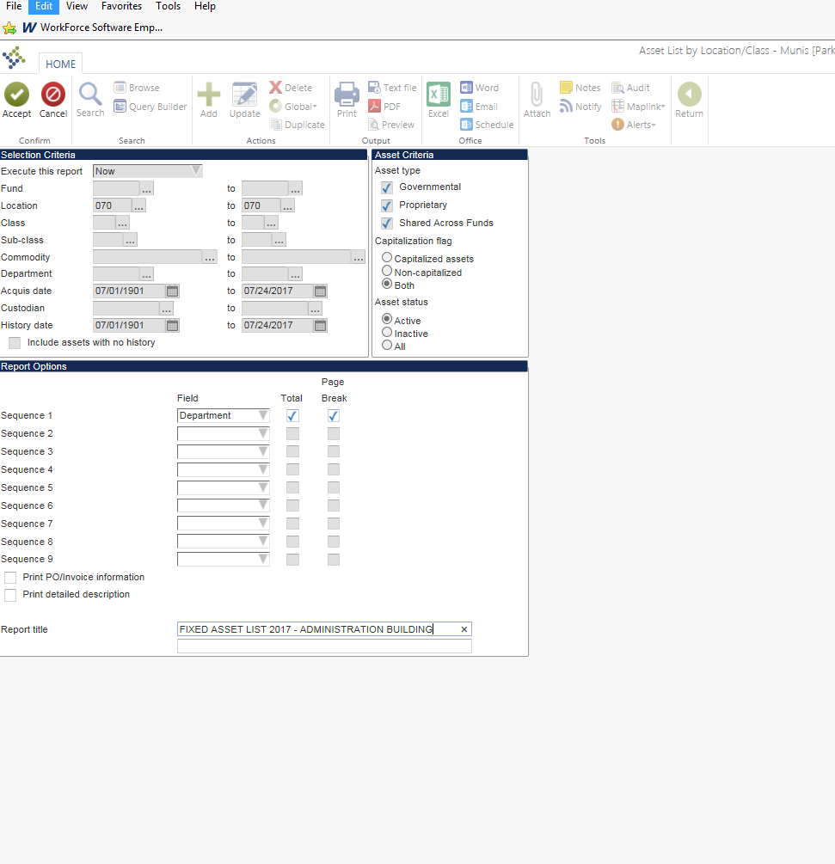

Click Accept. The Asset count will display on the bottom of your screen. Click the PDF icon to get a report of all the assets for your physical inventory.

Finance will send out a reminder e-mail in December with specific due dates.

Things to keep in mind when you are doing inventory:

* Make your notes easy to read and decipher. A single line through an item that needs to be deleted is easy to understand. If you like to use highlighters, add a color key so Finance knows what each color means.
* Turn them in on time. The end of the school year is too busy to be worrying about taking a physical inventory.
* If assets have transferred to another department or another school, I need to know where they are. Please list the school and department that has the transferred asset.
* Technology is replaced more frequently than other assets. Please have your TS check your inventory report for technology items.

*What is a fixed Asset?*

* Land, Buildings, machinery, furniture and other equipment
* Used for more than 1 year
* With an individual item cost over $1000.00
* Shipping adds to the cost of an item
* “Fixed” indicates probability or intent to use asset and not immobility of an item

*How do I indicate a Fixed Asset?*

On the line detail screen be sure that you add a “Y” to the Fixed Asset box, as well as making the expense account a 40 or 41.

*Why are Fixed Assets important?*

Fixed Assets are tracked and depreciated for DESE and our auditing purposes.

*Who do I ask if I have questions?*

Please contact Christy Groner or Deb Nolan in the Finance Department.

*What should I look out for?*

* Shipping and Handling
* Installation on a separate receipt/invoice
* Itemized Receipts

**Fixed Assets Criteria**

*\*\*This information is applicable to non- bond related projects within the district\*\**

**Land Improvement vs. Building Improvement vs. Equipment vs. Repairs**

Land Improvement- refers to projects that improve the overall value of the property, and would take significant amount of time, money and manpower to move. Overall they add to the usefulness of the land itself. Examples include:

* Repaving or Adding a patio to the cafeteria
* Playground gravel and swing set
* Baseball field improvement

Building Improvements- refers to projects or renovations made to existing buildings that extends the buildings useful space or overall life. Examples include:

* Upgrading the pipes in the bathroom, new toilets, and new sinks included
* Construction to reconfigure the layout of an existing area.

Equipment- large, independent items that could be moved from one room to another and remain usable and identifiable. Examples:

* Refrigerator in a reconfigured kitchen
* Computers/ Servers/ SMART boards
* Office Furniture/ desks

Repair/ Maintenance- a large repair that can be over $5,000.00 that is fixing something specifically broken. Examples:

* Fixing plumbing with a root in it
* Repairing a hole in the roof
* Fixing a drainage problem at a school building

**Reasoning Through It**

The best way to think of this is your house. If you add a retaining wall to your property, to make is safe for your family. This is considered a land improvement because it extends the ability to use the land. When you update your entire kitchen, there are only certain things that you can take with you when you move. If you add square footage to the kitchen, new plumbing, cabinets, flooring, and sinks, these are considered building improvements because these are installed and affixed to the structure and won’t come with you if you move. The refrigerator, dishwasher, microwave, and blender, can and usually come with you when you move. They can move relatively independently, these would be considered equipment. If your current gutter leaks water into your basement, fixing your gutter so that it no longer leaks into your basement is considered repairing an item.